MY PROJECTS



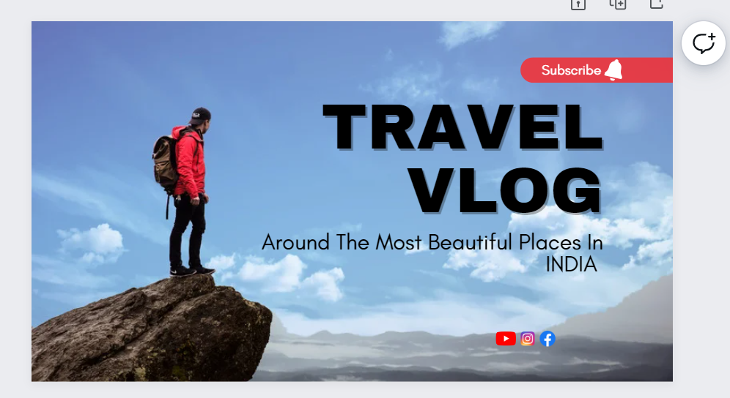

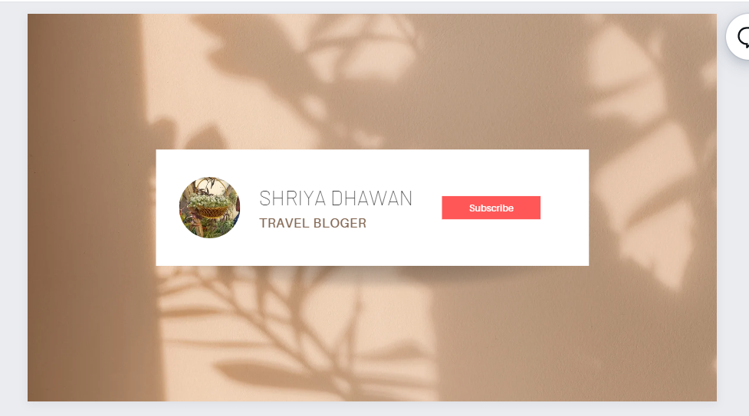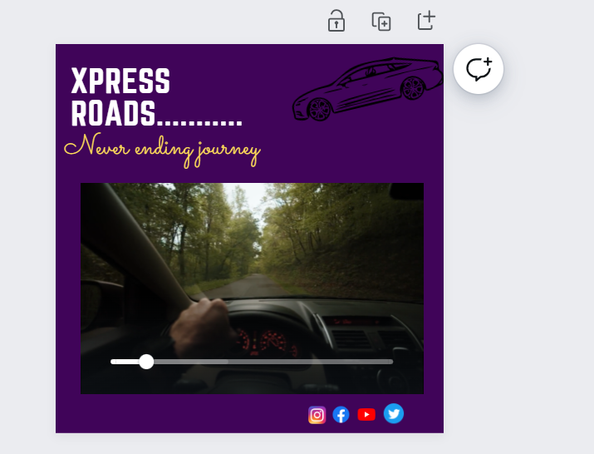

<https://infogram.com/biography-on-khushwant-singh-1h8n6m3pwvq7j4x?live>

PLEASE OPEN THIS LINK TO SEE MY INFOGRAM PROJECT

ALSO I HAVE EXPERIENCE IN USING GIMP, ADOBE PHOTOSHOP, CANVA , LOGO MAKER, PICSART, KODU, UNITY, SCRATCH, PIVOT, DA VINCI RESOLVE ,FIGMA,BLENDER,FILMORA.